Statistical Studies As A Means Of Inductive Thinking In The Field Of Education

Muhammad Novel RIfqi¹, Helen Diantini², Kayla Zahra Setiawan³, Rita Aninda⁴, I Ketut Mahadirka⁵, Kendid Mahmoudi⁶

^{1,2,3,4,Faculty} of Teacher Training and Education, University of Jember, Jember, Indonesia
 |  | Abstract
Received:  Revised:  Accepted: | 5 June 2022  10 June 2022  13 June 2022 | Statistical studies in education play a role important role in quantitative research. It works as a powerful, enabling inductive thinking tool researchers to uncover deep patterns and relationships education data. This discussion explores the significance ofstatistical representation in research quantitative and its role in improving our understanding of education. This emphasizes how statistical representation is not only simplify complex data but also generate new knowledge in the field education. By examining its use in various aspects of educational research, this discussion highlights the challenges and benefits of statistical representation in education and its important role in provide policy information and decisions decisions in the education sector.
Keywords: |  | Statistics, Inductive Thinking, Education
(*) Corresponding Author: |  | ketut.fkip@unej.ac.id
How to Cite: Simin, G., & Safinas Mohd Ariff Albakri, I. (2022). Teaching Critical Thinking in English Subject. International Journal of Education, Information Technology, and Others, 5(3), 61-72. https://doi.org/10.5281/zenodo.6679613

INTRODUCTION
In the era of increasingly developing information, education plays an important role in shaping the quality of human resources. Educators must use a data-based approach to improve the efficiency and effectiveness of the learning process. Statistics is one of the most useful tools in educational data analysis because it is not only useful for data collection and analysis, but also as a means of inductive thinking.
Inductive thinking is a logical process in which generalizations are made based on specific observations or data. This inductive thinking process is very important in educational research because it can help in the development of better educational theories and practices. In the context of Education, inductive thinking is very relevant because many educational phenomena are complex and multidimensional. By using statistics, researchers can identify patterns and relationships. For example, the analysis of Statistics can help us understand more deeply the factors that influence student achievement, the effectiveness of certain teaching methods, or the impact of educational policies.
Along with the development of technology and wider access to information, the use of data in education is becoming increasingly crucial. Previous research has shown that the use of statistics in education can provide in-depth insights into the effectiveness of teaching methods, analysis of student achievement, and evaluation of educational policies. As in the study by Maryati and Priyatna (2018) showed that statistical literacy skills among students are still low, so a new approach is needed in learning statistics to improve their understanding of data. In addition, research by Tiro et al. (2018) also revealed that students often face difficulties in statistical tables and graphs, which indicates the need for more effective teaching integration.
Statistics as a means of inductive thinking allows researchers to identify patterns and relationships in educational data. By using statistical analysis, researchers can find trends that may not be visible in descriptive analysis alone. This is in line with the opinion of Fajriah et al. (2020) who emphasized that statistical representation not only simplifies complex data but also produces new knowledge in the field of education. Through this approach, researchers can develop new hypotheses and theories based on empirical evidence obtained from data analysis.
Although the use of statistics in educational research is increasing, there are still some issues that must be considered when using it. Many teachers and researchers have difficulty applying appropriate analysis techniques or do not understand the basic concepts of statistics. Therefore, it is very important for educators to understand how to use statistics as an inductive thinking tool.

RESEARCH METHODS
In this study, we use a literature review that discusses aspects related to the learning achievement of elementary school students in grade III of SD Inpres Lanraki II using statistics as a means of inductive thinking in the field of educational science. Researchers will review previous literature studies. To explain the variables discussed in the literature this time, it must be relevant, both in soft copy and text form. The selection of this study is based on selective results from several cases that discuss educational problems regarding the influence of learning methods on student learning outcomes. This study uses a purposive sampling technique in determining the sample. The sample selected was class III A students, totaling 30 people, consisting of 12 female students and 18 male students.
This study uses questionnaires, observation, and documentation as the main techniques in data collection. Data analysis was carried out through two approaches, namely Descriptive Statistical Analysis and Inferential Statistical Analysis. To test the research hypothesis, an inferential statistical analysis was carried out, which began with a prerequisite test in the form of a data normality test. Hypothesis testing aims to determine the differences in students' science learning interests before and after learning using video media. The analysis of these differences was carried out using the Paired Sample t-Test with the help of Statistical Package for Social Science (SPSS) software.

RESEARCH RESULT AND DISCUSSION
- Descriptive Statistical Analysis
Literature using the case of the use of video media in science learning in grade III of SD Inpres Lanraki II has been proven to have a positive impact on increasing students' interest in learning. This is based on the results of observations made on students and teachers. Based on observations during the science learning process using learning videos, the results of its implementation are summarized in the following Literature using the case of the use of video media in science learning in grade III of SD Inpres Lanraki II has been proven to have a positive impact on increasing students' interest in learning. This is based on the results of observations made on students and teachers. Based on observations during the science learning process using learning videos, the results of its implementation are summarized in the following table.

Based on the table analyzed by the literature, it was found that the learning process consists of several stages, namely opening activities, delivering material using learning videos, re-explaining the material, providing reinforcement, and closing activities. Each stage is observed and measured based on three indicators that have been determined for each aspect. In the opening activity, the indicators include the teacher greeting and asking how the students are, providing apperception, and conveying learning objectives. In the stage of delivering material using videos, the indicators are that the teacher provides a brief explanation of the contents of the video to be displayed, focuses students' attention on the learning video, and plays videos that are relevant to the material. Furthermore, in the stage of re-explaining the material, the indicators include re-explaining the contents of the video, using language that is easy for students to understand, and giving students the opportunity to ask questions or express their opinions. In the stage of providing reinforcement, the indicator is giving appreciation such as words of praise, for example "good" or "smart." These learning steps have been implemented well by the teacher during three meetings. The percentage of implementation shows an increase, namely 71.42% in the first meeting, and 92.85% in the second meeting and third. The percentage is calculated by dividing the indicator score achieved by the maximum score, then multiplied by 100%.
To find out the description of students' learning interests, the researcher used a pretest. A questionnaire that had been validated by experts was given to students as a data collection instrument. The questionnaire consisted of 15 positive statements and 15 negative statements with four answer choices, namely (a) very appropriate, (b) appropriate, (c) inappropriate, and (d) very inappropriate. The questionnaire data were then processed and presented in a table for quantitative analysis.

a. Pretest Data of Student Learning Interest in Natural Sciences
The quantitative score of the student pretest was obtained by summing the scores from the questionnaire answers given by each respondent, based on the frequency of their answer choices.

Table 3. Pretest Frequency Distribution Table of Student Answer Results
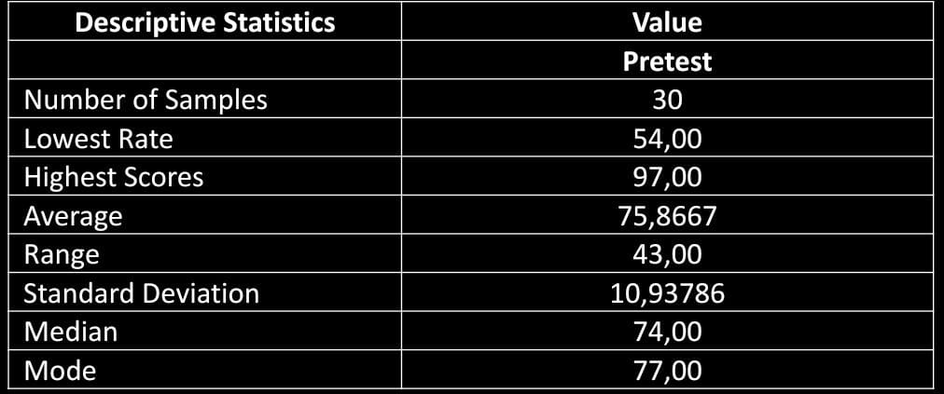

The results of the descriptive analysis obtained the lowest value of 54.00 and the highest value of 97.00 accumulated to get the average value of 75.8667. The value that appears most often, or has the highest frequency, is 77.00. The value range, which indicates the quality of the data, is calculated from the difference between the maximum and minimum values. The data range in this study is 43.00, where the smaller the value range, the better the data quality, and vice versa. The standard deviation obtained was 10.94, indicating that there was a variation in the data group. Standard deviation is used as an indicator of group homogeneity; The smaller the standard deviation value, the more similar or uniform the existing data is. Conversely, a larger standard deviation value indicates a more diverse variety of data.
The results of the descriptive analysis of students' pretest answers related to the bound variable, namely science learning interest, are presented as follows.
Table 4. Student Pretest Qualifications and Intervals
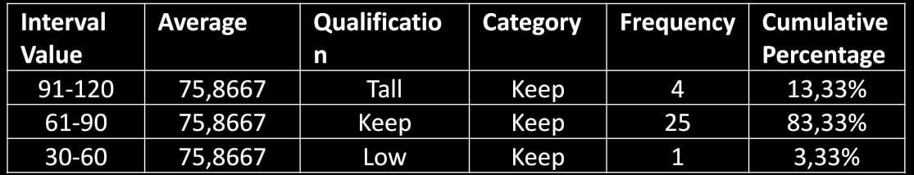

The literature explains that how to see the picture of students' learning interests, the research uses a pretest before students get material through learning videos, which was obtained from 30 students. A total of 1 student (3.33%) revealed that their interest in learning science was in the low category. Meanwhile, 25 students (83.33%) stated that their interest in learning was in the medium category, and 4 students (13.33%) indicated that their interest in learning was in the high category.
Based on this explanation, it is known that students' interest in learning science before being given treatment is in the medium category. This can be seen from the analysis of the answers to the pretest questionnaire, where several indicators of learning interest show low scores. These indicators include: 1) Feelings, 2) Student engagement, 3) Student interest in the subject, and 4) Student interest in the subject. Learning interest in the medium category is due to several aspects that are still lacking, such as low feelings of like, lack of student involvement in learning, and lack of student interest in science lessons.

b. Posttest data of students about their interest in learning Natural Sciences
The determination of the quantitative score of the student posttest is the sum of the questionnaire answer scores from the respondents according to the frequency of answers.

POSTEST
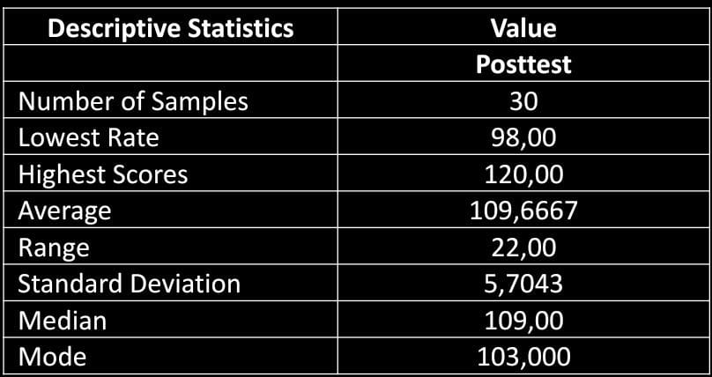
Based on the table, of the 30 students sampled, it was known that the lowest score was 98.00, while the highest score reached 120. The average score of students in this study was recorded at 109.67, with the most frequent score, or having the highest frequency, which was 103. The value range, which is the difference between the maximum and minimum values, is 22.00. This range reflects the quality of the data; The smaller the range, the better the data quality, and vice versa. The standard deviation in this study was 5.71, indicating low data variation in the group. Standard deviations are used to assess the homogeneity of data; The smaller the standard deviation value, the more uniform the data is, while the larger standard deviation indicates higher data variation.
The results of a descriptive analysis of students' posttest answers related to the bound variable, namely science learning interest, are presented as follows:
The data in the table shows that all students stated that their interest in learning science was in the high category. This shows that after learning science using videos, students' learning interest that was previously in the medium category increased to the high category.

- Inferential Statistical Analysis
Inferential statistical analysis is used to test research hypotheses with the help of the Statistical Package for Social Science (SPSS) software. Before testing the hypothesis, a normality test is carried out to determine whether the data is normally distributed or not.
a. Data Normality Test
The criteria for the normality test are as follows: if the value of sig. (2-tailed) > 0.05, then the data is considered normally distributed; conversely, if sig. (2-tailed) < 0.05, then the data is considered not normally distributed.
Based on the results of the analysis using SPSS, a sig . (2-tailed) for pretest of 0.436 and for posttest of 0.865. Since the values of 0.436 and 0.865 are greater than 0.05, it can be concluded that the data is normally distributed. Therefore, the data can be continued to the next stage, which is hypothesis testing.
The results of the data normality test using SPSS are presented in the following table.

- Data Normality Test
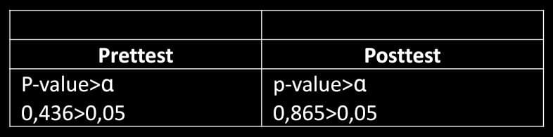
- Uji Hipotesis
After confirming that the pretest and posttest results are normally distributed, the next step is to carry out a hypothesis test. This test aims to determine whether the use of science learning video media has an influence on the learning interest of third grade students of SD Inpres Lanraki II, Tamalanrea District, Makassar City. The data analysis process is carried out using SPSS software with certain testing criteria.
- If the value of sig. (2-tailed) > 0.05, then Ho is accepted.
- If the value of sig. (2-tailed) < 0.05, then Ha is accepted.
The results of the SPSS analysis showed a sig . (2-tailed) by 0.000. Since the value of 0.000 < 0.05, it can be concluded that Ho is rejected and Ha is accepted. This means that there is a significant influence of the use of science learning video media on the learning interest of third grade students of SD Inpres Lanraki II, Tamalanrea District, Makassar City.
- Results of Literature Analysis
Research by Hamzah Pagarra and Nur Abidah Idrus shows that the use of learning video media has a significant influence on the learning interest of third grade students of SD Inpres Lanraki II, Tamalanrea District, Makassar City. Learning videos have the ability to influence students emotionally through the display of materials or teaching materials that are presented concretely. Thus, the use of video media in learning will create an effective learning experience, which is not only beneficial for students, but also for teachers and parents in supporting the educational process.

- Inductive thinking process
- Observing data from the literature
Before the application of the use of science learning videos to the learning interests of third grade students of SD Inpres Lanraki II, most students had moderate learning interest in science subjects; After the application of the use of science learning videos to the learning interests of third grade students of SD Inpres Lanraki II, all students showed high interest in learning science.
- Identifying Patterns
In the application of the use of science learning videos to the learning interests of grade III students of SD Inpres Lanraki II significantly affected the learning interest of students, it can be seen from the accumulated results of the pretest and posttest showing a significant influence from the medium category to the high category.
- Compose Generalizations
The use of learning methods, especially those that combine sound and movement, has been proven to help students in the learning process. As we know, learning videos can directly affect students, both emotionally through the presentation of concrete material. Therefore, the use of learning videos can create an effective and efficient learning field not only for students, but also for teachers and parents and requires full support from parents in the learning process.

CONCLUSION
Based on this data, it can be concluded as follows:
1. The use of video media in science subjects in grade III of SD Lankari II has a positive impact on improving student learning outcomes, as evidenced by the results of the analysis that show an increase in the interest of students and teachers from each meeting.
2. Before being given treatment, students' learning interest was at the level of the medium category. However, after the use of learning video media, students' interest increased significantly, with all students achieving a high category in Natural Sciences learning. This indicates a significant improvement between the conditions before and after the treatment was given.
3. Based on the results of the hypothesis test, it was found that the use of science learning video media had a significant influence on the learning interest of grade III students at SD Inpres Lanraki II, Tamalanrea District, Makassar City.
Based on these conclusions, suggestions that can be put forward are:
1. For Teachers: Teachers are advised to continue to apply a supportive approach, especially by using learning video media in Natural Sciences in grade III of SD Inpres Lanraki II. The use of this media is important because it has been proven to increase students' interest in learning.
2. For Students: It is hoped that students can be more active and participate in learning activities in the classroom to support.
3. For Schools: To develop teachers' teaching skills, schools are advised to provide additional facilities and support, such as installing LCD projectors in each classroom or providing other devices that support the use of learning video media.
4. For Researchers: For researchers who will research the use of video media in increasing students' interest in science subjects, it is recommended to pay full attention and observe students in detail during the observation process, so that data collection can be carried out more optimally.
BIBLIOGRAPHY
Amir, J., & Nukuhaly, N. A. (2023). Means of scientific thinking in the field of mathematical and statistical languages. 6(2).
Asih, D., & Hasanah, E. (2021). Student management in improving the achievement of elementary school students. AoEJ: Academy of Education Journal, 12, 205–214.
Fajriah, N., Utami, C., & Mariyam. (2020). Analysis of Students' Mathematical Representation Ability on Statistical Material. Journal of educational review and research, 3(1), 14–24.
Firmansyah, & Ali, M. (2021). Means of scientific knowledge (philosophical review). 2(2), 1–23.
Mudjiyanto, B., Lusianawati, H., & Launa. (2023). Dynamics of Media Studies: From Agenda Setting, Construction Agents, Means of Representation, to Social Consensus Tools. 5(1), 943.
Pagarra, H., & Idrus, N. A. (2018). The Effect of the Use of Science Learning Videos on the Learning Interest of Grade III Students of SD Inpres Lanraki 2, Tamalanrea District, Makassar City. 8(1), 30–40.
Sumarni, E., Yurna, Y., & Adawiah, E. R. (2023). Scientific Thinking Facilities (Language, Logic, Mathematics and Statistics) Eti Robiatul Adawiah. Journal of Character Education, 1(4), 106–122.
Wicaksono, W. A., Suyanto, I., & Salimi, M. (2016). Inductive thinking model: analysis of cognitive processes in inductive thinking models.

