Lecturer Research Management Information System Iakn Manado

Willy Armando Rondonuwu, Olivia Cherly Wuwung, Jhoni Lagunsiang

IAKN Manado

 |  | Abstract
Received:  Revised:  Accepted: | 07 July 2025  16 July 2025  23 July 2025 | The management of lecturers’ research at the State Christian Institute of Manado (IAKN Manado) was previously conducted manually, resulting in administrative delays and difficulties in monitoring. Furthermore, the existing system lacked integration and did not support real-time collaboration among lecturers, administrators, and reviewers. This study aims to develop a Lecturer Research Management Information System application designed to simplify, accelerate, and improve the accuracy of research management, while integrating the values of High Touch and High Tech in its implementation.  The development method employed was Extreme Programming (XP), comprising the stages of planning, design, coding, and testing. The resulting application features proposal uploads, document validation, automated notifications, progress monitoring, and real-time report generation. The integration of High Touch and High Tech values ensures that the system is not only technologically functional but also promotes relationships, academic ethics, and Christian values.  Testing results indicate that the application meets user requirements and is ready for implementation at IAKN Manado. Future development recommendations include integration with national publication databases (SINTA and Garuda), mobile application development, enhanced data security through layered encryption and two-factor authentication, as well as user training to maximize system utilization.
Keywords: |  | Information System, Research Management, Extreme Programming, High Touch, High Tech
(*) Corresponding Author:
How How to Cite:

INTRODUCATION
The Management Information System in education is an inseparable part of the overall educational process. Without proper management, educational goals cannot be achieved efficiently, systematically, and with ease of access. This concept applies to all educational institutions that require effective and efficient management, meaning it should be functional and facilitate the administration process.
The State Christian Institute of Manado (IAKN Manado) is a Christian higher education institution in North Sulawesi that prepares scholars who excel in Christian education, theology, arts, and socio-religious studies for the advancement of Indonesian civilization. One of the main pillars in realizing the institution’s vision and mission is through lecturers’ research activities. Lecturers’ research not only aims to advance knowledge but also serves as an obligation in fulfilling the Tridharma of higher education, namely research.
Initial observations revealed several challenges in managing lecturers’ research at IAKN Manado. The administrative processes—from proposal submission, monitoring, to final reporting—are still largely conducted manually. This results in delays, data inaccuracies, and difficulties in compiling information on a regular basis.
Based on these preliminary findings, several issues were identified: first, administrative inefficiency, as data recording and storage still rely on physical documents or files submitted via forms, which are prone to loss or damage; second, limited access to information, as lecturers often struggle to obtain updates regarding proposal status, monitoring schedules, and reporting deadlines; third, inadequate monitoring and evaluation, due to the absence of an integrated system that enables continuous supervision of research progress; and fourth, manual data compilation, which makes institutional reporting time-consuming and prone to errors.
These problems provide the basis for developing a practical research management model through the implementation of an information system application. Such an application offers a potential solution to improve the efficiency of research management by automating administrative processes, simplifying information access, and accelerating data processing.
Therefore, this study aims to develop a lecturer research application to enhance the efficiency of research management at IAKN Manado by integrating the values of High Touch (relationships, spirituality, Christian values) and High Tech (the use of digital and interactive technology). With this application, it is expected that research submission, monitoring, and reporting processes can be carried out more effectively and efficiently. Hence, this study is titled “Lecturer Research Management Information System at IAKN Manado.”

METHODS
Research Location and Time
This study was conducted at the State Christian Institute of Manado (IAKN Manado). The selection of this location was based on its relevance to the research objective, namely the development of a lecturer research management information system at IAKN Manado. The research was carried out from January to June 2025.
Research Materials and Tools
The materials and tools used during the study consisted of both software and hardware.
- Software
    - Windows 10 operating system
    - Visual Studio Code for application development
    - XAMPP as a local server including MySQL
    - Google Chrome browser for user interface testing
    - Go/Golang
    - Git
    - Postman
    - Node Modules
    - React JS Library
- Hardware
    - Laptop with minimum specifications:
        - Intel Core i5 processor
        - 8GB RAM
        - 256GB SSD
    - Internet connection for research purposes and testing of the web-based application
Research Method and Design
In this study, the researcher applied a mixed method approach, combining qualitative and quantitative research (Creswell, 2010:5). For the qualitative part, data were collected through observation and interviews to be analyzed as system requirements. For the quantitative part, the researcher measured the objectivity and impact of the product to be analyzed statistically.
In developing the product, the researcher used the Extreme Programming (XP) method for software development. Extreme Programming is a software development model that simplifies various stages of system development to be more efficient, adaptive, and flexible (Riko et al., 2024:122). This method involves four stages: Planning, Design, Implementation (Coding), and Testing (Pressman, 2012).
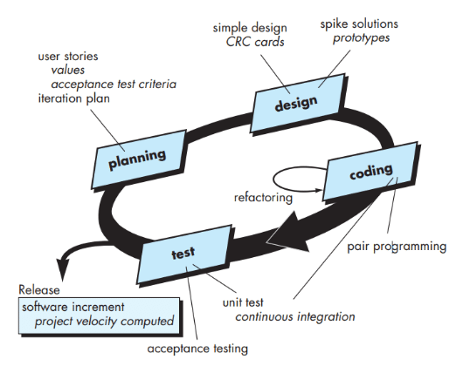
Figure 1 Extreme Programming Method Flow (Pressman, 2012)
- Planning
At this stage, system requirements are identified based on the results of observations and interviews. User stories are developed together with users to prioritize the features to be implemented.
- Design
The system design is carried out in a simple yet flexible manner. The user interface (UI) is designed using Figma, taking into account ease of navigation and user experience (UX).
- Implementation (Coding)
Code development is performed iteratively and collaboratively, with module distribution based on user stories. The programming language used is PHP with the Laravel framework, along with HTML, CSS, and JavaScript for the frontend.
- Testing
Testing is conducted periodically at the end of each development iteration. The techniques used include unit testing to evaluate separate parts of the code and user acceptance testing (UAT) to ensure the system meets user requirements.
Data Collection Methods
- Observation
Observation was carried out on the ongoing process of lecturer research management at IAKN Manado to identify system requirements as well as challenges faced by users.
- Literature Review
A literature review was conducted by studying references related to management information systems, software development methods, as well as journals and books that support the theoretical foundation of this research.
- Interviews
Interviews were conducted with users, in this case, lecturers at IAKN Manado and the institution responsible for research management.

RESULT AND DISSCUSSION
A. Research Results
- Planning
At the initial planning stage, the researcher conducted a user needs analysis as the basis for developing the research article management information system for lecturers at IAKN Manado. This process began with observation and problem identification, as described in the previous chapters. From these observations, several main issues faced by the institution and lecturers in managing research articles were identified, including:
  - Administrative Inefficiency
The procedure for managing articles is still carried out manually and in a fragmented manner, which slows down the process of data input, validation, and archiving.
  - Difficulty in Accessing Information
Lecturers face difficulties in obtaining up-to-date information regarding article status, review processes, or publication because a centralized and easily accessible information system is not yet available.
  - Lack of Monitoring and Evaluation
Monitoring activities for submission, review, and publication processes are not well documented, making it difficult to evaluate lecturers’ performance as well as management effectiveness.
  - Manual Recapitulation
All administrative reports, including the number of submitted articles, manuscript status, and authors, are still compiled manually, making them prone to errors and delays.
Based on the identification of these problems, the researcher formulated system requirements in the form of user stories, which serve as the foundation for the iterative process of application development. This stage is consistent with the principles of the Extreme Programming method, which emphasizes close collaboration with users and adaptability to changing needs.
- Admin User Requirements
  - Admin logs in using a username and password.
  - Admin can update/edit data.
  - Admin creates accounts for users (lecturers).
  - Admin can create and monitor data input for reporting purposes.
- Lecturer Requirements
  - Lecturers log in using a username and password provided by the admin.
  - Lecturers fill out research forms in the application.
  - Lecturers fill out community service (PKM) forms.
  - Lecturers can change their passwords.
- System Requirements
  - The system provides access for the admin to manage data.
  - The system provides access for lecturers to input data.
  - The system stores research data entered by lecturers.
- Design
The system design for the Lecturer Research Article Management Application was carried out in a simple yet flexible manner, following the core principles of the Extreme Programming method, which emphasizes minimalist, easily modifiable, and directly applicable designs. The design included use case diagrams, activity diagrams, database structures, and user interface design.
- Usecase diagram
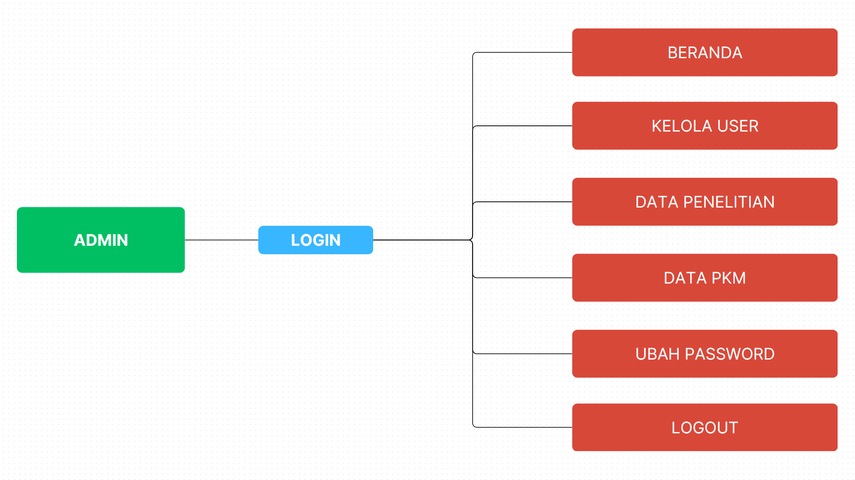
Figure 2 usecase diagram Admin

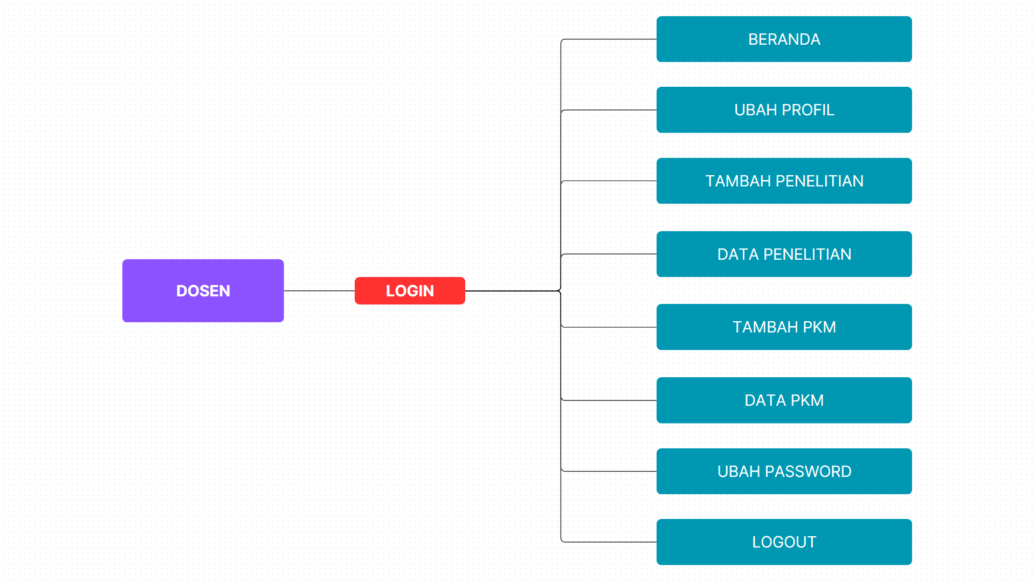
Figure 3 usecase diagram Dosen

The use case diagram defines the relationship between system users and the system. In this diagram, the admin logs in, manages users, research data, and community service (PKM) data, while lecturers, after receiving a user account from the admin, can add research data, PKM data, view the list of research, and also change their password.
- Implementasi (Coding)
The next stage is the implementation of the previously designed plan into the code of the lecturer research management information system, starting with the development of the web on the main page.
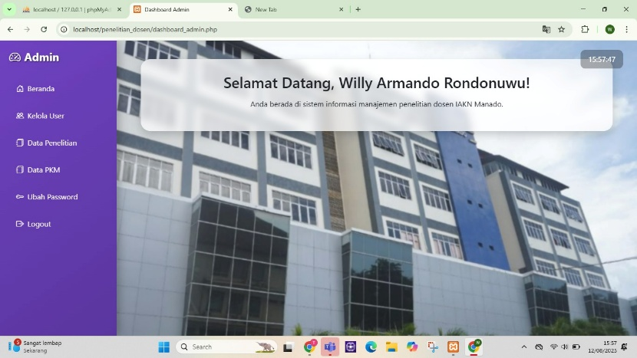
Figure 4 halaman utama admin
The admin main page allows the admin to create lecturer accounts for lecturers who will input research data under the Manage Users section, which then displays the Lecturer User List as well as the option to input PKM data.
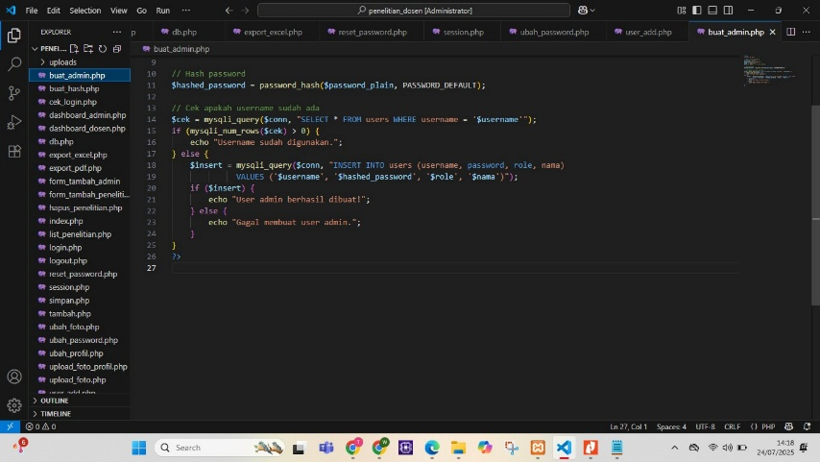
Figure 5 kode program buat admin
This program is a PHP script used to add a new admin user into the database.

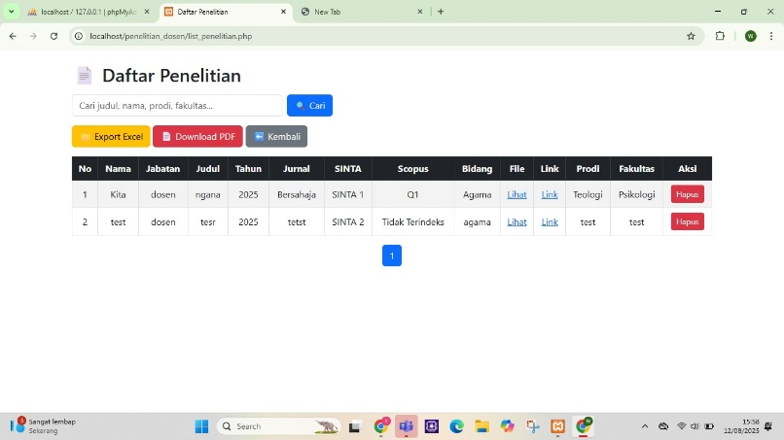
Figure 6 Daftar Penelitian Dosen
This figure displays the research data entered by lecturers, making it easier to monitor and recap lecturers’ research data.
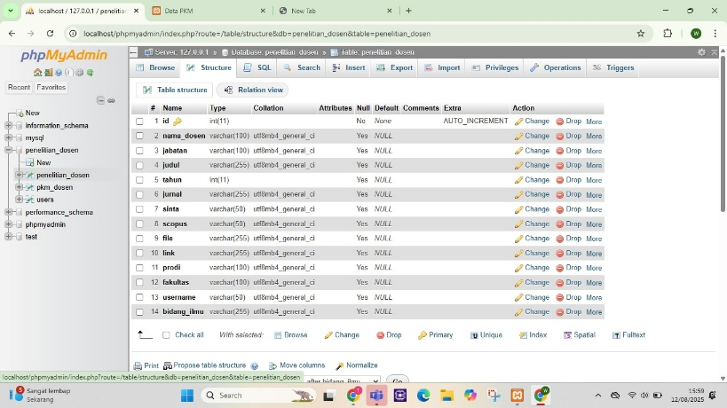
Figure 7 Tampilan Admin Daftar Penelitian Dosen
This figure shows the structure of the lecturer research list, displaying the research data that has been input by lecturers.

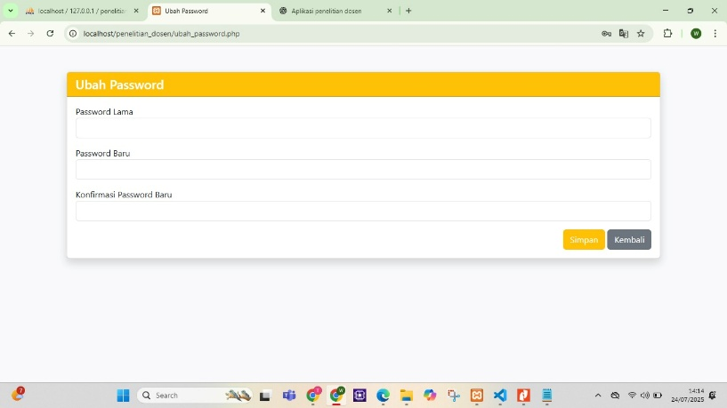
Figure 8 halaman ubah password
On this page, the admin can change the admin account password periodically as needed.
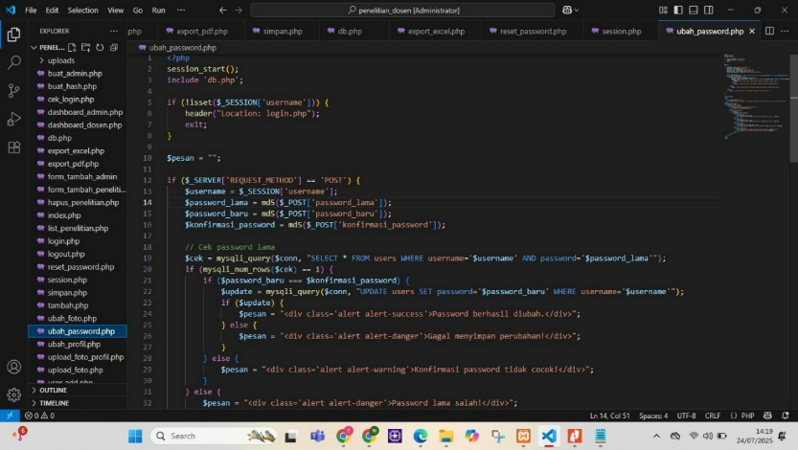
Figure 9 kode program ubah password
The figure shows ubah_password.php, a PHP script used to change user passwords in the lecturer research information system.
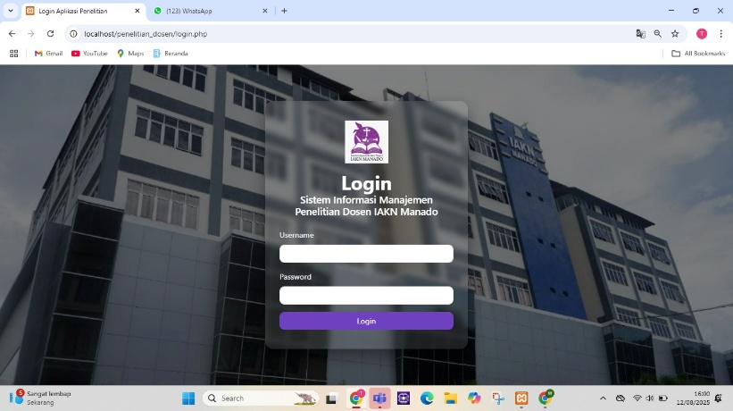
Figure 10 halaman login data penelitian dosen
After receiving an account from the admin, lecturers are directed to the main research data page to log in.
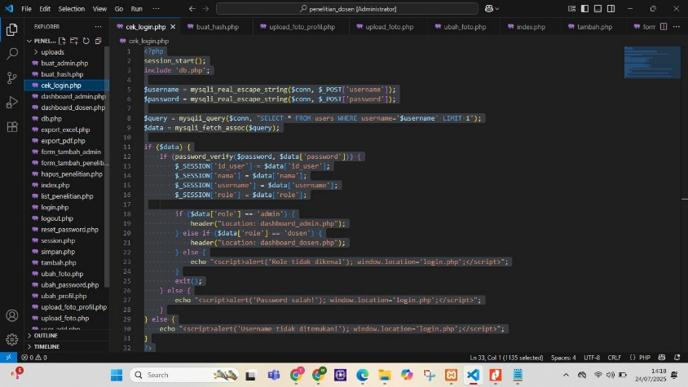
Figure 11 kode program cek login
This script is used for the login authentication process in the application, including initialization, input retrieval, user data lookup, data validation, role-based redirection, and error handling.
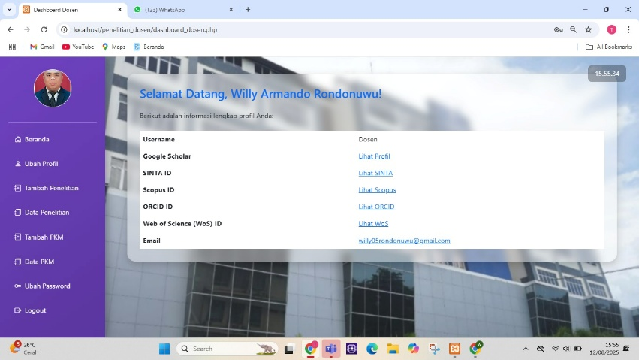
Figure 12 halaman utama data penelitian dosen
After logging in, lecturers can manage their accounts for research data, including uploading a profile photo, adding research, and viewing the list of submitted research.
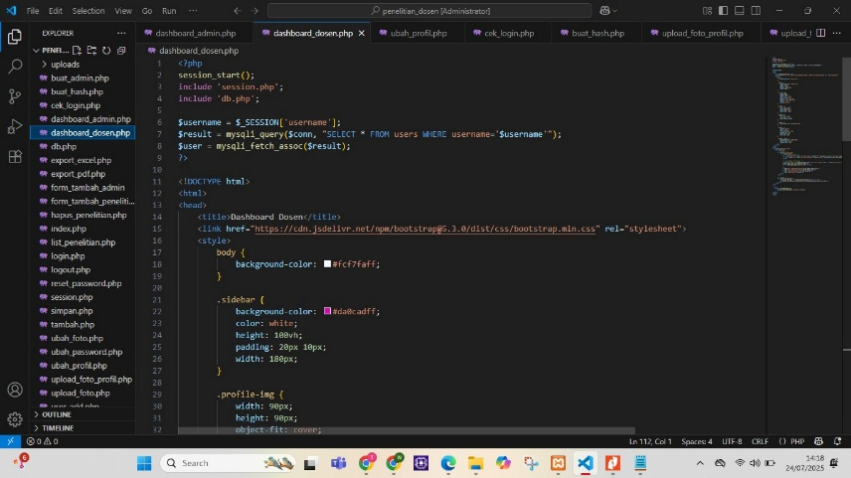
Figure 13 kode program dashboard dosen
The figure displays PHP code in the dashboard_dosen.php file, which functions as the main dashboard page for users with the lecturer role.
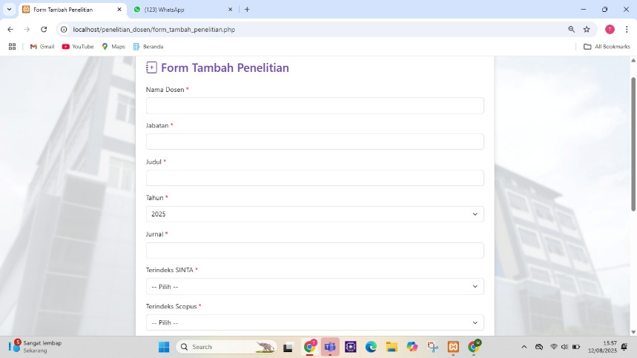
Figure 14a halaman form tambah penelitian
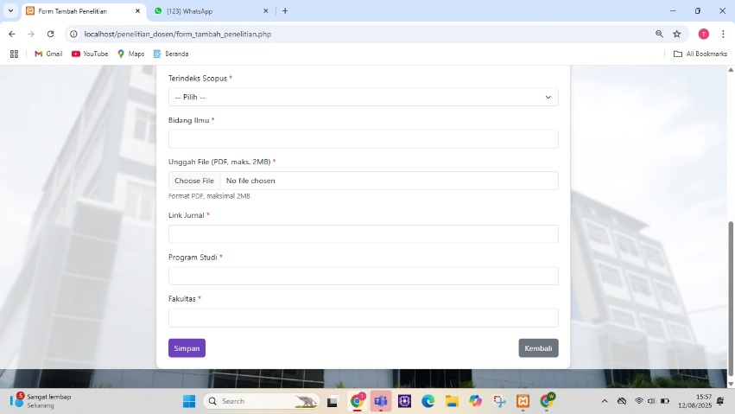
Figure 14b halaman form tambah penelitian
These figures show the form page for lecturer research data, where lecturers input research data according to the provided format.
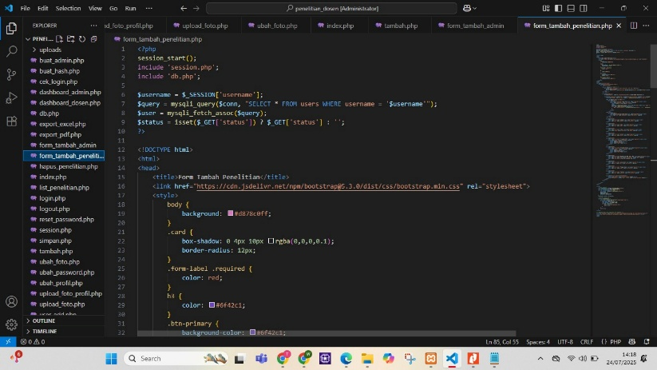
Figure 4.15 kode program form tambah penelitian
The figure shows form_tambah_penelitian.php, a PHP file used to display the input form for new research in the lecturer research management system.
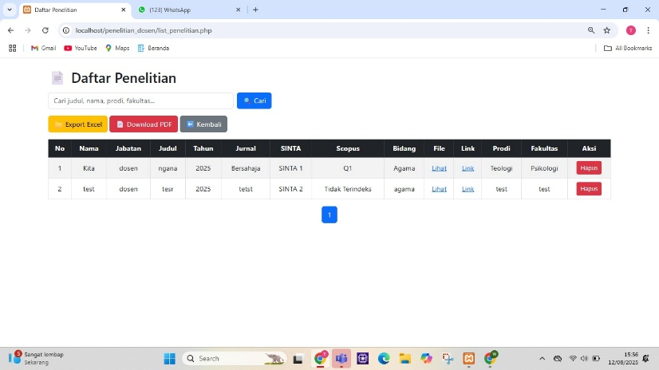
Figure 4.16 halaman data-data penelitian pada akun dosen
This page displays the research data entered by the lecturer.
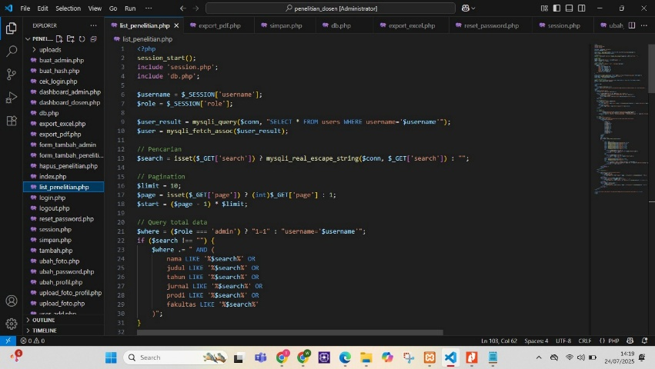
Figure 4.17 kode program list penelitian
The figure shows list_penelitian.php, a PHP file used to display the list of lecturer research in the system, complete with search and pagination features.
- Testing (Pengujian)
Testing of the Lecturer Research Article Management Application was conducted periodically at the end of each development iteration, following the principles of the Extreme Programming (XP) method, which emphasizes a rapid and iterative cycle of build–test–feedback.

No | Feature Tested | Type of Testing | Test Scenario | Expected Result | Status
1 | Admin Login | Unit Testing | Enter valid username and password | Admin successfully logs into the dashboard as assigned | Success
2 | Admin Login | Unit Testing | Enter incorrect password | System denies access and displays an error message | Success
3 | Create Lecturer Account | Unit Testing | Enter lecturer data | Admin successfully creates an account | Success
4 | Lecturer Login | Unit Testing | Enter valid username and password | Lecturer successfully logs into the dashboard as assigned | Success
5 | Admin Login | Unit Testing | Enter incorrect password | System denies access and displays an error message | Success
6 | Input Research Data | Unit Testing | Enter lecturer research data | Lecturer successfully adds research data | Success
7 | Input PKM Data | Unit Testing | Enter PKM data | Lecturer successfully adds PKM data | Success
8 | Change Password | Unit Testing | Change password | Password successfully changed | Success

Table 1 pengujian Aplikasi

Testing of the Lecturer Research Article Management Application was carried out periodically at the end of each iteration using unit testing and user acceptance testing (UAT). Unit testing was conducted to verify that each module functioned according to specifications. The results showed that most modules, such as login, data input, and research listings, performed well. A bug was found in the file format validation feature, where the system initially accepted uploads other than PDF. This issue was immediately resolved by adding format checks on the server side, and retesting confirmed the expected outcome.
User acceptance testing (UAT) involved lecturers and administrators as end users. UAT assessed the system’s compliance with user requirements as formulated in the user stories. Most users stated that the application’s navigation was easy to understand and that the data input process was efficient. One suggestion was the need for clearer notification displays. After design adjustments, user satisfaction increased significantly.
Overall, the test results indicated that the application met the planned functional requirements, with minor improvements that could be accommodated in subsequent iterations. The Extreme Programming approach supported rapid, adaptive, and user-oriented development.
C. Discussion
- Analysis of Lecturer Research Management Process
The study results showed that the research management process at IAKN Manado was still conducted manually, from proposal submission to final reporting. Each document had to be submitted in print and processed through lengthy administrative procedures. Data recapitulation was also performed manually, requiring a long time and being prone to recording errors. Administrative delays frequently occurred due to the lack of a system capable of monitoring research progress in a centralized and real-time manner.
- Identification of the Current Research Management System
The findings indicated that the current system was still limited to digital document storage without features supporting monitoring, evaluation, or user collaboration. Lecturers were unable to directly submit research data, while administrators struggled to compile research progress reports quickly. The absence of integration between lecturers, reviewers, and the Research and Community Service Institute (LPPM) resulted in slow coordination, making it difficult to achieve the target of increasing research and scientific publications.
- Design and Development of the Lecturer Research Management Information System with the Application of High Touch and High Tech
As a solution to these problems, a lecturer research management information system was designed and developed using the Extreme Programming (XP) method. This method allows for adaptive and iterative application development, ensuring that user needs are accommodated quickly. The system includes features such as proposal uploads, document validation, research progress monitoring, and integrated reporting.
The application of High Touch values is reflected in the system design, which promotes harmonious interaction between lecturers and administrators while upholding honesty and academic integrity in line with Christian values. Meanwhile, High Tech values are realized through a responsive web interface, simple navigation, and real-time data access across devices.

CONCLUSION
Based on the results of analysis, development, and application testing, it can be concluded that:
- The process of managing lecturers’ research at IAKN Manado is still manual, relying on printed documents, requiring a long time, prone to recording errors, and often causing delays due to the absence of a centralized system capable of monitoring research progress in real time.
- The current research management system at IAKN Manado is still limited to digital document storage without monitoring, evaluation, and collaboration features. These limitations make it difficult for lecturers to submit research data directly, for administrators to compile reports, and for coordination among lecturers, reviewers, and the Research and Community Service Institute (LPPM) to run effectively, thus hindering the achievement of research and publication targets.
- The application developed using the Extreme Programming method is able to meet user needs through features such as proposal upload, document validation, notifications, progress monitoring, and automated reporting. The integration of High Touch and High Tech values makes the system not only functional from a technological perspective but also supportive of good relationships, academic ethics, and Christian values. Testing results indicate that the application aligns with user requirements and is ready to be implemented within IAKN Manado.

REFERENCES
Alhadi, Bani Ilham, (2022). Sistem Informasi Manajemen (SIM) sebagai Sarana Pencapaian E-Government, Jurnal STIE Semarang: Vol. 14 No. 2 Edisi Juni.
Anggreani, Leni, dkk, (2023). Metodologi Penelitian, Indramayu: Penerbit Adab
Bertalanffy, L. Von, (1968). General System Theory: Foundations, Development, Applications. New York: George Braziller.
Creswell, John W., (2010). Research Design: Pendekatan Kualitatif, Kuantitatif dan Mixed, Edisi III. Yogyakarta: Pustaka Pelajar.
Davis, G. B., (1991). Introduction to Information Systems. New York: McGraw-Hill.
Hadiat & Syamsurijal, (2023). Dasar-dasar Manajemen, Bandung: CV. Harva Creative
Ikhsan, Nur, Sokibi Petrus, dan Fahrudin, Rifqi, (2023). Perancangan Desain antarmuka Pengguna dengan Metode Lean Ux pada Aplikasi Sistem Informasi Desa Cibentang Berbasis Android, Jurnal Sosial dan Teknologi (SOSTECH): Volume 3, No. 9.
Indrajit, R. E., & Djokopranoto, R. (2005). Konsep dan Aplikasi Sistem Informasi. Yogyakarta: Andi.
Jogianto, H. M. (2005). Analisis dan Desain Sistem Informasi. Yogyakarta: Andi.
Kambey, Roy, (2022). Kepemimpinan Gereja berdasarkan Efesus 4:11-17 dan Implikasi dalam Menjalankan Fungsi Kepemimpinan Hamba Tuhan. Jurnal Ilmu Teologi dan Pendidikan Agama Kristen. STT Jaffray.
Kendall, K. E., & Kendall, J. E. (2006). Systems Analysis and Design (7th ed.). New Jersey: Pearson Education.
Kia, A Dan, & Majesty, Gilbert Timothy, (2025). Konstruksi Pendidikan Agama Kristen di Era Disrupsi. Bandung: Widina Media Utama
Laudon, K. C., & Laudon, J. P. (2007). Management Information Systems: Managing the Digital Firm (10th ed.). New Jersey: Pearson Prentice Hall.
Makkaraka, Andi Muh Reza B. dkk., (2024). Design of Web-Based Student Academic Information System. Ceddi Journal of Education, Vol. 3 No. 2 December.
Manik, Keke Teguh dkk., (2022). Makna Kata Figure dan Rupa dalam Kejadian 1:26-28. Coram Mundo: Jurnal Teologi dan Pendidikan Agama Kristen. sttarastamar
McLeod, R., & Schell, G. (2001). Management Information Systems (8th ed.). New Jersey: Prentice Hall.
Muslihudin, Muhamad, & Oktafianto, (2016). Analisis dan Perancangan Sistem Informasi: Menggunakan Model Terstruktur dan UML, Yogyakarta: Andi
O'Brien, J. A., & Marakas, G. M. (2010). Introduction to Information Systems (15th ed.). New York: McGraw-Hill.
Pressman, R. S. (2012). Rekayasa Perangkat Lunak. Yogyakarta: Penerbit Andi.
Purnamawati, Siti Nuraini, dkk., (2022). Development of a Website-Based Education Management Information System in Inclusive Schools, Indonesian Journal of Education Research and Review, Vol 5 No. 3
Putra, Riko, dkk (2024). Konsep Sistem Informasi, Kota Jambi: PT Sonpedia Publishing Indonesia.
Rusdiana & Irfan, (2014). Sistem Informasi Manajemen, Bandung: Pusaka Setia.
Satzinger, J. W., Jackson, R. B., & Burd, S. D. (2004). Systems Analysis and Design in a Changing World. Boston: Thomson Course Technology.
Sidik, Firman, (2022). Pendekatan Teori Sistem Input, Proses dan Output di Lembaga Pendidikan, Irfani: Jurnal Pendidikan Islam Vol. 18 No. 1 Mei.
Stair, R., & Reynolds, G. (2008). Principles of Information Systems (8th ed.). Boston: Cengage Learning.
Sugiyono, (2017). Metode Penelitian Pendidikan. Alfabeta.
Supriyadi, Dede, (2018). Aplikasi Penelitian Dosen Berbasis Web, Jurnal Teknologi Informasi ESIT: Vol. XII No. 01 April
Sutarbi, Tata, (2012). Konsep Sistem Informasi, Yogyakarta: Andi.
Terry, George R., & Rue, L.W., (2019). Dasar-dasar Manajemen, Jakarta: Bumi Aksara
Wijaya, Vanessha, Joeanca, Vyorennity, Yap, Hendrik, Lim, Stanley, (2024). Methodical Approach: Building a Web-Based Warehouse Management System Using the Waterfall Method, International Journal of Computer Science and Information Technology (IJISIT), Volume 1, No. 1
Yudiyana, I Made Gede, Sumicha, Andrew, Ariyani, Ni Wayan Sri, (2018). Management Information System of Event Organizer, International Journal of Engineering and Emerging Technology, Vol. 3, No. 2, July—December.

